**COMPUTER ORGANIZATION AND ASSEMBLY LANGUAGE**

**LAB TASK 05**

Aliza Rizvi

58782

**TASK 1**

Take a two-digit number and display it in reverse order (e.g., 23 → 32)

**Code:**

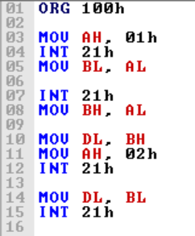

**Output:**

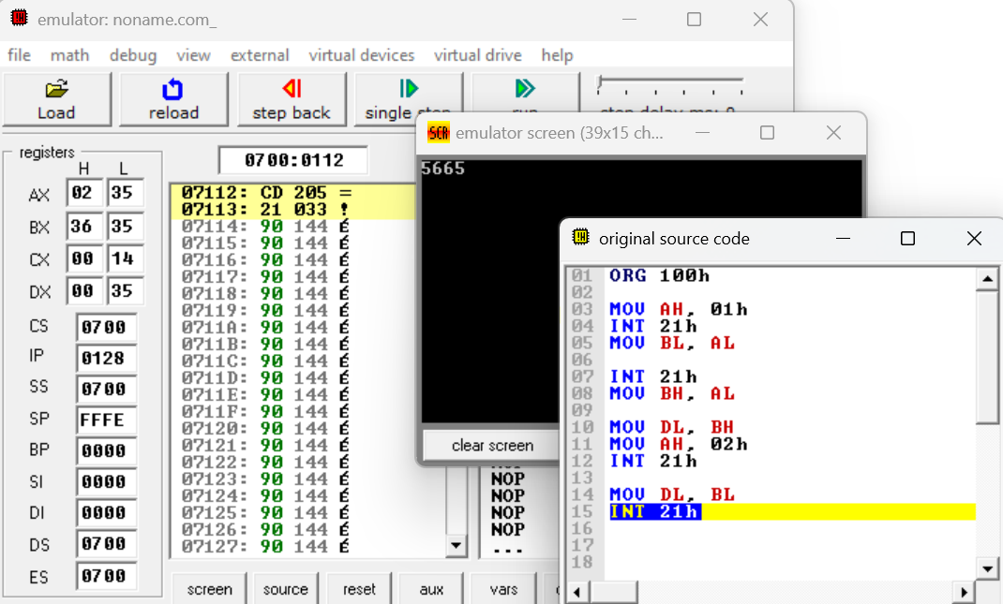

**Task 3:** Evaluate this expression: 3+5-6

**Code:**

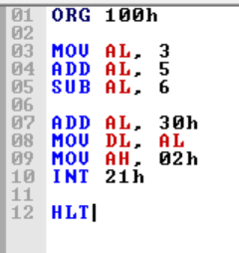

**Output:**

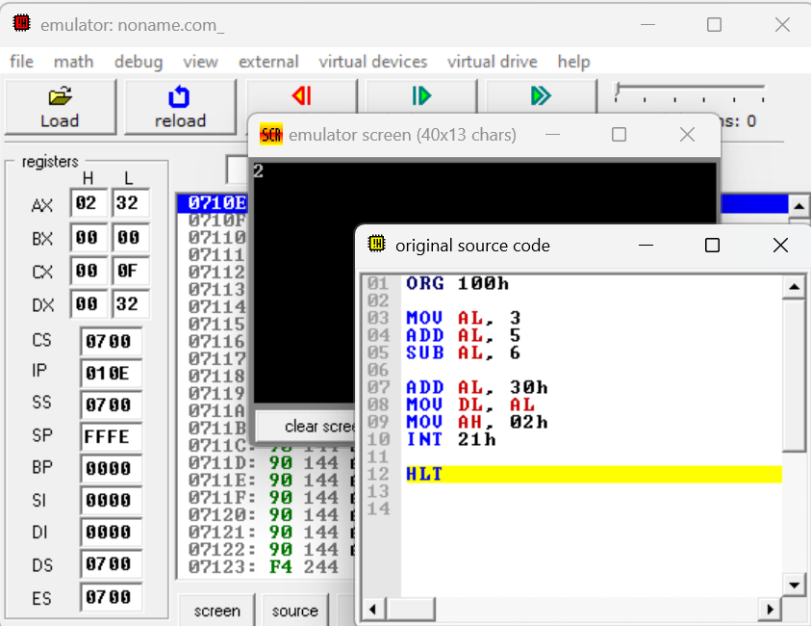

**Task 4:** Input two single-digit numbers, store them in registers, swap their values before displaying them

**Code:**

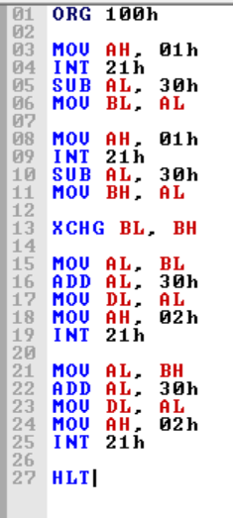

**Output:**

